Moving Head bubble machine
(Waterproof)
Product user manual

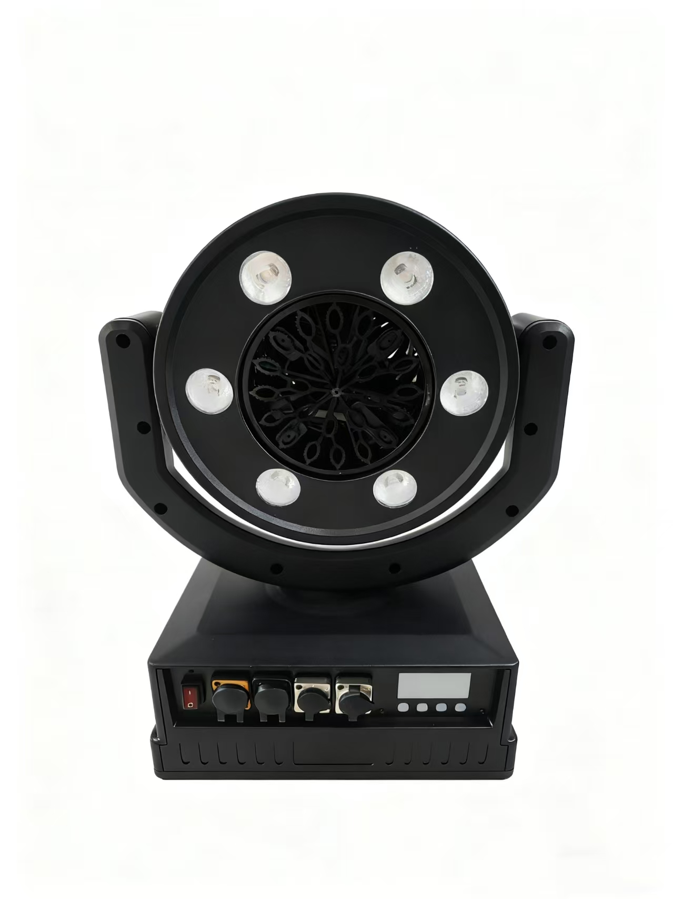

(Please read the instructions carefully before use)
CATALOGUE

- The Title Page Of a Thread-Bound Book
- Catalogue
- Product Presentation
- Safety Warnings And Precautions
- Security Certificate
- Technical Parameter
- Preparation And Operation Steps Before Use
- Cleaning And Maintenance
- Debugging
- Warranty &Amp; Service
- Appendix
light source

- product presentation
dmx plug
power plug
tank
turntable
control button
Control interface display

(2) Product features
-Small size, easy to use: easy to carry and store, suitable for all kinds of occasions.
-Multi-angle adjustment: the foaming Angle can be flexibly adjusted to meet the needs of different scenarios.
-Powerful coverage: indoor height up to 11 meters, outdoor range up to 300 square meters, quickly create a bubble world.
-Fireworks and bubble effect: 6 RGBW LED lights can render the effect of fireworks and bubbles at night, adding a happy and romantic atmosphere.
-High efficiency foaming: up to 1000 bubbles per second, quickly filling the space.
-Professional bubble water: It is recommended to use the original professional bubble water to ensure the best effect.
-Highest grade fan: Customized industry's highest waterproof rating IP68 to ensure wind power while extending service life

(3) Applicable scenarios
-Indoor parties, children's playgrounds, festivals and celebrations, wedding venues, cultural tourism attractions, concerts, music festivals, courtyard decoration, etc.

II. Safety warnings and precautions

(1) Safety warning
-Do not place the machine in a humid, high temperature or inflammable and explosive environment to avoid damage to the equipment or cause danger.
-Do not soak the machine in water or expose it to heavy rain for a long time, so as not to damage the equipment
-Do not let children use the device alone, it should be used under the supervision of an adult, in case of accident.
-Please read this manual carefully before use and follow the instructions to ensure safety.

(2) Usage notes
1. The bubble outlet of this machine can not be rotated 360° to avoid damage to the internal structure.
2. The speed of the turntable should not be adjusted too fast, otherwise bubbles may not appear.
3. The pump speed should not exceed 180 rpm, otherwise it may cause water leakage.
4. Do not keep the lights on for more than 30 minutes without turning on the fan, so as not to affect the service life of the equipment.
5. The best effect can be achieved when the ratio of bubble water to water is 1:2. Too much or too little may affect the foaming effect.
6. This machine can not be used continuously for more than 7 hours to avoid power damage.

III. Security certification
This product has passed the following safety certification to ensure compliance with relevant safety standards, you can use it at ease:
-CE certification: in compliance with the safety, health and environmental protection requirements of the European Union, certification number: FCS202412801CA01

IV. Technical parameters
Model | BB1008
Voltage | 110v-240v 50/60 Hz
Power | 90w
Source | Led 8w RGBY
Control Mode | DMX512 Remote
Dmx Channel | 9 channel
Angle | up and down 180° left and right 270
Spray Distance | 11 meters
Water Tank Capacity | 1.7 litres time to use 1 hour
Waterproof Level | IP65
Material Quality | ABS
Net Weight | 4.2 kg
Gross Weight | 4.8 kg
Product Size | 30*25.5*42cm
Package Size | 45*29.5*39cm

V. PREPARATION FOR USE

(1) Installation steps
1. Open the package and check whether the product is complete, including the main engine, remote control, instructions, power cord and other accessories.
2. Insert the power cord into the power interface of the host and connect it to the power socket.
3. Open the lid of the water tank, add an appropriate amount of original bubble liquid and pour in clean water to shake it evenly, ensuring that the water level is within the specified range of the water tank.
4. Insert the suction pipe into the water tank and close the lid to ensure good sealing.

(2) Initial Settings
1. Press the "MENU" key on the main engine to enter the setting interface. Long press the "MENU" key to adjust the value of the pump and turntable.
2. Use the "UP" or "DOWN" key to select the appropriate parameters, such as console address code, wind gear, etc.
3. Press the "ENTER" key to save the Settings and return to the previous interface.

(3) Control interface description
The keys from left to right are: menu, add, subtract, confirm
Corresponding to screen printing: MENU UP DOWN ENTER
menu

(1) d001 console address code; Range: 001-512; modify by press the add/subtract key, press the confirm key to save
(2) E000 Wind medium and high range: E000-E001
(3) C000 Optical switching range: C000-C018
(4) AUOF automatic remote head range: AU00 open; AUO1 open Angle; AUO2 open Angle.
(5) P000 Angle positioning Range: P000-P255
(6) S000 Automatic Remote Head Speed Range: S000-S255

- Power on and Start

1. Press the power button on the main engine to start the equipment.
2. Use the remote control or console to control the equipment, select the desired lighting effect and wind gear.
3. Adjust the speed of the turntable and the pump to achieve the ideal foaming effect.

(1) Control console control usage method
-Console address code setting:
-In the host setting interface, press "MENU" to select the console address code option.
-Use the UP or DOWN keys to adjust the address code, ranging from 001 to 512.
-Press the "ENTER" key to save the Settings and return to the previous interface.

-DMX channel functions:
-
channel | numeric value | function
1CH | 0-9 | close
1CH | 9-255 | The wind is picking up
2CH | 0-255 | Turn on the LED at different heights and colors
3CH | 0-255 | red
4CH | 0-255 | blue
5CH | 0-255 | hispid arthraxon
6CH | 0-255 | Amber yellow
7CH | 0-255 | location by angle
8CH | 0-255 | 0-9 turn 10-255 automatic head shaking wide Angle
9CH | 0-255 | 0-910-255 Auto shake small Angle

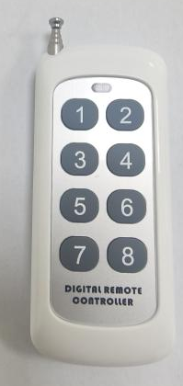
- How to use the remote control:
Key 1: Start high wind power.
Key 2: medium wind power.
Key 3: Switch on the lights.
Key 4: Switch off the lights.
Key 5: Off
Key 6: Small angle shake head
Key 7: Large angle shake head
Key 8: Moving head positioning

VII. Cleaning and maintenance

Cleaning methods
- Wipe the surface of the equipment with a soft dry cloth and avoid using corrosive cleaning agents.
2. When cleaning the tank, first pour out the bubble water in the tank, and then rinse the tank with clean water to ensure cleanliness.
3. After each use, replace the water and continue to run for 1-2 minutes to avoid clogging of the bubble outlet
4. Clean the fan and bubble outlet regularly to avoid dust and debris blocking.

Maintenance recommendations
1. If you do not use it for a long time, please pour out the bubble water and clean the tank to avoid bacterial breeding or damage to the equipment.
2. Check the power cord and plug regularly to ensure that the connection is firm and undamaged.
3. Avoid storing the equipment in a humid or high temperature environment to prolong the service life.

VIII. Troubleshooting

Common problems and solutions
problem description | Possible causes | resolvent
No bubble | Not enough bubble water or the wrong ratio | Check the water tank level and adjust the ratio of bubble water
 | The rotation speed is too fast or too slow | Adjust the turntable speed
 | Water pump failure | Check whether the water pump is working normally
Lights are not bright | Lights not on or lights faulty | Check the lighting setting and check whether the lamp is damaged
Lack of wind power | Fan failure or improper wind setting | Check if the fan is working properly and adjust the wind setting

IX. Warranty and Service

Warranty policy
-This product enjoys one year limited warranty service from the date of purchase.
-The warranty covers replacement and repair of parts that are not damaged by human beings.
-The warranty does not cover damage caused by improper use, modification or unauthorized repair.

X. Appendix

Terminology explanations
-RGBY: Red, green, blue and yellow LED beads used to render color effects
-DMX512: A digital communication protocol for lighting control

